**Bank Loan Query Document**

1. **BANK LOAN REPORT | SUMMARY**

**KPI’s:**

Total Loan Applications





MTD Loan Applications





PMTD Loan Applications





Total Funded Amount





MTD Total Funded Amount





PMTD Total Funded Amount





Total Amount Received





MTD Total Amount Received





PMTD Total Amount Received





Average Interest Rate





MTD Average Interest





PMTD Average Interest Rate





Avg DTI





MTD Avg DTI





PMTD Avg DTI





**GOOD LOAN ISSUED**

Good Loan Percentage

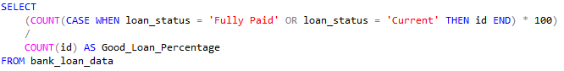



Good Loan Applications





Good Loan Funded Amount





Good Loan Amount Received





BAD LOAN ISSUED

Bad Loan Percentage

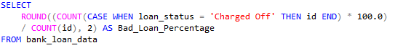



Bad Loan Applications





Bad Loan Funded Amount





Bad Loan Amount Received





LOAN STATUS

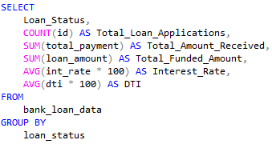

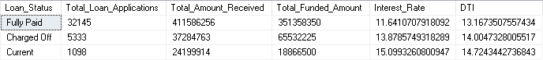

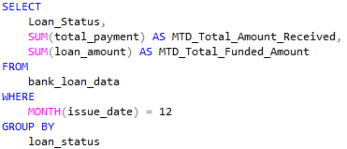

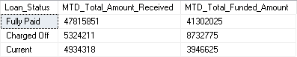

1. **BANK LOAN REPORT | OVERVIEW**

**MONTH**

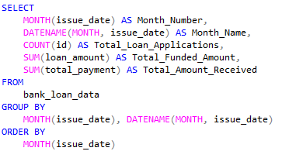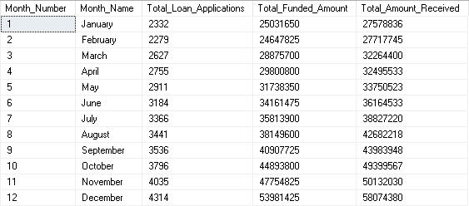

**STATE**

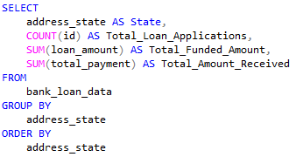

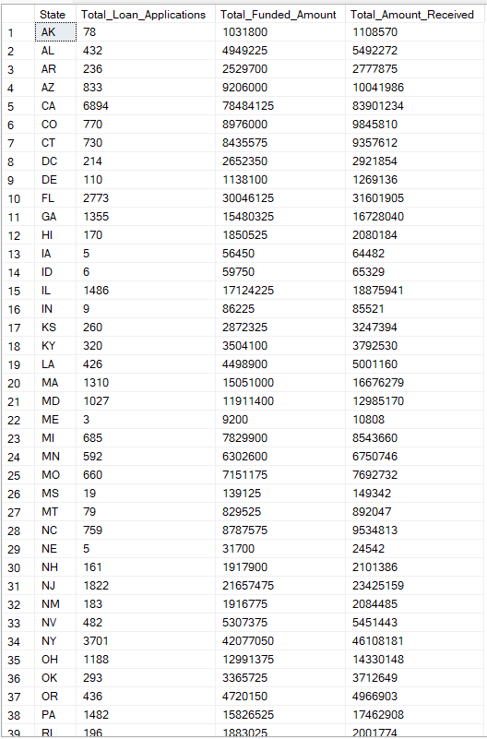

**TERM**

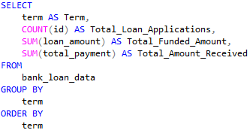



**EMPLOYEE LENGTH**

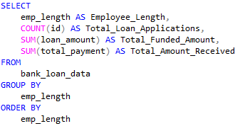

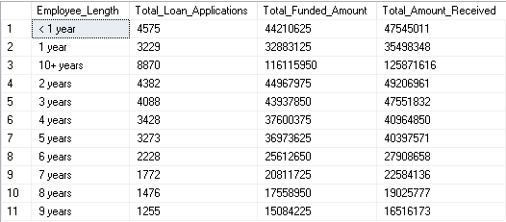

**PURPOSE**

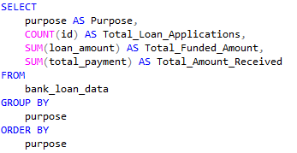

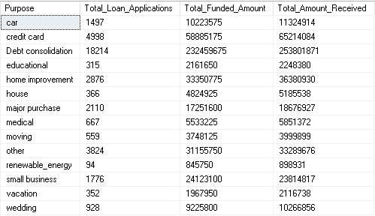

**HOME OWNERSHIP**

